Project Report

On

College Management System

Submitted in partial fulfillment of requirement for the award of the Degree BCA.

Bachelor of Computer Application

Of M.C.R.P.Y BHOPAL

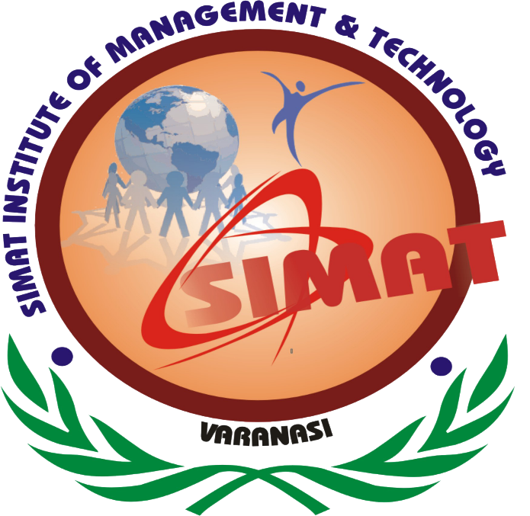

Session: 2017-2020

Under The Guidance Submitted By

Mr. Mohammad Sadik Mohammad Faisal